
Letter to the Board

Michael Havens
Superintendent of Schools
Phone: 315-524-1001 Fax: 315-524-1049 mhavens@wayne.k12.ny.us

June 5, 2009

Board Agenda:

- Executive Session: We will meet at 6:30 to discuss the superintendent hearing appeal of Mrs. Schultz, mother of Brett Dinehart. Brett was suspended for the first semester of next year but may return after ten weeks provided he meets certain criteria. Please read Mrs. Schultz’s attached letter and my memo regarding the issue. The principals and I will be there to answer any questions you have. It is not our role to plead to case or to try to convince you what you should do. The memo and letter should be the basis of your decision.

- Elementary Foreign Language Presentation: Mrs. Cox will provide you with a progress update on her feasibility study of an elementary foreign language program. See her attached letter.

- Graduation: We will be reminding you of place, times, and gowns for the 2009 ceremony. Also think about whether you would like to wear hoods for the 2010 graduation.

- 3-8 Math Results: I gave you an overview of the numbers in last week’s letter. Mrs. Cox will provide you with some nice looking graphs, showing how we have done.

- Financial Update: Mr. Atseff will provide his monthly report.

- Student Representative: The student rep for this meeting is Sophomore Class Officer, Sean Morgan. Sean is a 2 year Varsity Cross Country team member (4 years on the cross country team), 3 year JV Basketball player, 2 year Varsity Track team member (4 years on track team).

- Business Items: The board will have personnel and CSE/CPSE action for approval, The April Treasurer’s Report is attached for your review. We have a gift to the district from Frito Lay, the BOCES cooperative bid for technology and art supplies, and a health contract with Canandaigua City School District. I am also requesting approval of the internship plans for Mrs. Barb Heald and Mrs. Donna Rizzo and the Power School plan.

Board Letter

1. Marijuana Parents: This week two students brought some marijuana in to their Health teacher, Mr. Molisani, Their parents were smoking it at home and the children were concerned for their parents (actually mom and boyfriend), themselves, and their 11 month old baby sibling. Our SRO took the lead and there was a search of the house by the State Troopers. The case is still ongoing but the children have not been removed from the home. We are continuing to provide support to the children here at school.

2. Main Street Clean Up: Last weekend OE students, teachers and the Ontario-Walworth Rotary club cleaned up Ridge Road. They edged sidewalks, put down mulch, planted flowers, painted fire hydrants, cleaned business windows and painted entrance ways. It was a great success and a good way to teach our elementary students about giving back to the community.

3. Kathy Green Retirement Party: There will be a retirement party for Kathy Green on June 17th at the Country Club. Please contact Mrs. Luke in Kim’s office if you would like to attend. It is a 4:30 -6:30 celebration.

4. Out of Town: Wendy and I are traveling to Orlando this weekend to visit Michael. We haven’t seen him since February, and those of you who have adult children know, you can only go so long before you need a visit (I just realized I sound like my mom). I’ll have my cell phone if you need me 315-576-0228.

5. Flags at half staff: Flags will be flown at half staff on Friday, June 5, in honor of a Fort Drum Soldier who died in Iraq on May 31. Specialist Marko M. Samson, whose home is Columbus, Ohio, died in a non-combat related incident near Tikrit.

6. Upcoming Events:

6/5 – FE 5th Grade Banquet
6/5 – Ed Currier Awards @ MS
6/8 – TCA Friends of Music Meeting @ MS Conference Room – 6:30 p.m.
6/9 – HS Chorus Concert @ PAC – 7:00 p.m.
6/10 – MS Band Concert @ PAC – 7:00 p.m.
6/11 – MS Awards Night @ PAC – 7:00 p.m.
6/13 – Heritage Square Country Days – Heritage Square Corners - Noon – 4:00 p.m.
6/16 – MS Chorus Concert @ PAC – 7:00 p.m.
6/16 – MS PTO Meeting @ MS Media Center – 6:30 p.m.
6/16 – NYS Regents Exams & Final Exams Begin
6/17 – OP 2nd Grade International Night @ OP – 6:30 p.m.

7 Attachments:
- Brett Dinehart Appeal Letter
- Brett Dinehart Hearing Comments from Supt. Havens
- Safety Committee Meeting Minutes
- Tom Siembor Letter
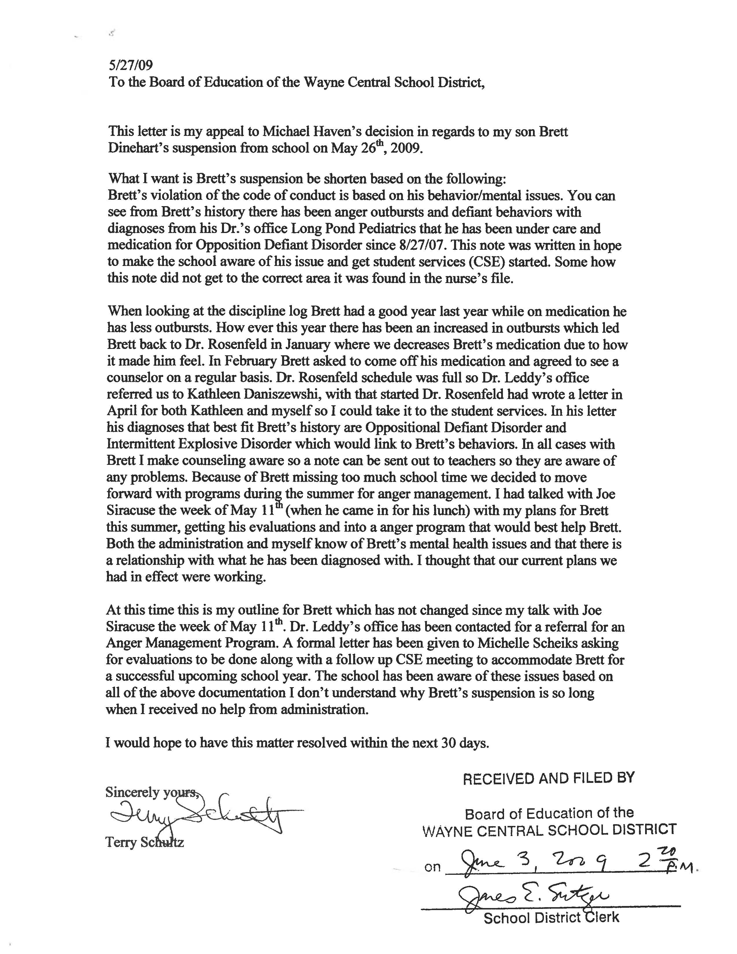
Memorandum

Michael Havens
Superintendent of Schools
Phone: 315-524-1001 Fax: 315-524-1049 mhavens@wayne.k12.ny.us

To: Board of Education
From: Michael Havens
Date: 6/3/09
Re: Superintendent Appeal
Attached is the written appeal of my superintendent’s hearing regarding Brett Dinehart. An appeal is not a retrying of the case. It involves the Board reviewing a written appeal of the parents, and the district overview of the events through this memo. During executive session you should decide whether you wish to overturn my decision. If you decide to do that, you will make a motion and vote to do so in regular session. If you decide not to overturn my decision then you need do nothing and the Board President will write a letter to Mrs. Schultz (his mom) stating you did not overturn my decision and his suspension is in effect.

A Superintendent’s hearing was held on Tuesday May 26 to consider the high school’s request for a long term suspension of Brett Dinehart. At the hearing Brett admitted to getting into an argument with a student in PE class over kickball rules. He admitted to calling the student a “fat fuck”. When told to leave the class he admitted saying to the student, “Fuck you Tim. You better watch your back. I’ll fucking kill you.” When located in a hallway by Mr. Marean and Trooper Chapman, Brett admits to saying to PE teacher Marean, “Fuck you, Fuck you Dave Marean. You are a fucking douche bag” Brett does not remember saying to Trooper Chapman, “fuck you too”, but was found guilty of the offense based on the testimony of both Mr. Marean and Trooper Chapman.

Based on this behavior and previous behavior, the high school administration requested that Brett be suspended until the end of the first semester next year. The high school principal expressed concern that Brett might harm another student and did not feel it would be safe to have him back in school. Some of Brett’s previous incidents have included;
- walking out of class,
- saying “fuck you” to a teacher,
- calling a teacher a, “bitch”,
- telling a teacher to, “shove it up your ass”,
- calling Mrs. Armitage, “a fucking cunt”.

All of these incidents occurred this year. There have been similar incidents in previous years.

The high school counseling department and administration have been working with Brett and his mother to control his anger. There have been frequent meetings with his mom, his counselor, administration and Brett regarding his anger. If Brett gets angry he is allowed to leave class and go to the guidance office where his counselor will meet with him to give him a chance to cool off.

Interestingly, Brett works at Hegedorn’s. He says he has a very difficult boss but that he has never “blown up”. He says that is because work is different than school. This would seem to indicate that Brett can control his anger if he is sufficiently motivated.

After considering the evidence, the prior incidents, the disruptions to the educational process and the safety of the other students, I ruled that Brett would be suspended for the fall semester but could come back to school on probation after ten weeks (November 2009). In order to do so, Brett would have to complete an anger management program, keep his grades up and not get in to any further trouble. It is my belief that bringing Brett back sooner and without these conditions will result in a more serious outburst from Brett. It is imperative that Brett complete an anger management program and that he be made to realize that there are serious consequences for his current manner of behavior at school.

TO: Safety Committee Members:
Chris Shaffer - Committee Co-Chairperson (MS Asst. Principal)
Fred Prince - Transportation
Maureen Doyle – MS PE
Tom Lucieer – OE Maintenance
Mark Callahan - DO Administration
Lori Sensenbach – OP SCRIP
Beth Peters– FE Instructional
Rob Chapman – SRO
Jacquie Brunner - School Board Rep.
Pat Griswold – OE Nurse
Riley Wheaton – HS Science

FROM: Bob Miller – Committee Co-Chairperson (Dir. of Facilities)
RE: Meeting Minutes
DATE: May 26, 2009

New Business

Fire inspection is scheduled for the window of July 15th – August 30th and will be performed by our BOCES health and safety representative.

The Ontario Primary School had a reportable fire on May 12th. There was a heat lamp used in a kindergarten classroom to keep newly hatched chicks warm. The bulb came into contact with the cardboard box housing the chicks and it started to smolder. The building alarm was pulled and the fire company responded. There were no injuries, to students or chicks. I purchased galvanized metal containers to replace the cardboard boxes.

I will be purchasing small key safes, called “Knox Boxes”, at the request of the Ontario Fire Company. They will be installed outside the main entrance of each building to house building access cards. These are used throughout the county by fire departments to gain entry to buildings, in case of emergency.

I updated the committee on the H1N1 flu. I outlined the cleaning procedures we were using during the outbreak. We have stocked up on disinfectant and hand sanitizer for a possible fall outbreak.

There was a question about procedures regarding the management of students in crisis when an administrator isn’t in the building. I will be talking with Michelle Scheik about this concern.

There was also a question regarding an office in the high school that exits into a classroom. I will be calling our BOCES health and safety representative to look into this.

Rob Chapman gave us a more detailed account about the recent suicide at Canandaigua school district.

Next meeting will be June 23rd at 8 am in the maintenance building

Robert Miller
Director of Facilities
Wayne Central School District
315-524-1045
Fax 315-524-1048



